SSLM
Simple Solution, Low Maintenance
Standard Operating Procedure

1. Purpose & Scope
SSLM is a lightweight, methodology-agnostic project management model. It provides a small set of standard documents and a governance rhythm that together let any project be run consistently, and let anyone — a project manager, an executive, or an auditor — reconstruct the complete story of a project along its critical path.
Why SSLM — what it improves
- One traceable story — a single Project Reference threads every document, so any project can be reconstructed end to end and is audit-ready by default.
- Consistency and a faster start — teams pick up a ready-made standard kit instead of rebuilding templates, so projects are comparable and week one isn’t lost to setup.
- Honest, low-effort visibility — status rolls up on a fixed cadence with the real colour reported, so problems surface early and the reporting effort shrinks as it goes up.
- Right-sized governance that scales — every project starts light and adds process only on a real trigger, scaling to a portfolio without a bespoke build.
- Disciplined start, continue or stop — initiatives are prioritised by strategic fit and value, and assurance keeps testing whether a project should continue; sunk cost is not a reason to persist.
- Proven value — benefits are baselined before go-live and checked at their horizon, with cashable savings distinguished from notional ones.
SSLM is methodology-agnostic — for how these gains apply under Waterfall, Agile and value streams, see the Delivery Methodologies Guide; for a leadership summary, see the Why SSLM one-pager.

1.1 Goal
Provide a ready-to-use document pack, backed by this SOP, so project teams can pick up a consistent set of templates rather than building project management artefacts from scratch each time.

1.2 Core decision this model drives
Every document in the model carries a single Project Reference forward from the point an initiative is prioritised. This turns twelve or more separate documents into one traceable narrative: what was proposed, what was approved, what changed, what was decided, and why.

1.3 Scope
SSLM is a generic model — it is not written for any single organisation. It is intended for internal project delivery and can be adopted by any team regardless of delivery methodology (Waterfall, Agile, or Hybrid).

1.4 Governance & Design Principles
Two layers of principles underpin the model. Governance principles (below) govern how a project is run; every other guide in this pack refers back to them by number. Design Principles govern how the solution itself is chosen and shaped, and are set out in full in the Design Principles Guide.
Umbrella — Anchor to purpose: serve the purpose over going through the motions. Self-check: Does this serve the purpose — and if not, why am I doing it?
- 1. Clear accountability & authority — one owner over split leadership. Rule: One accountable owner per project; authority delegated within agreed guardrails; forums decide and clear the path — they do not redesign the work. Self-check: Is it clear who owns this, and do they have the authority to decide?
- 2. Report the real colour — honest status over managed narrative. Rule: A status is reported as it is, not as hoped, smoothed, or politically convenient. An amber that is really red is worse than no report at all, because Principle 7 depends on an honest signal to trigger. Applies at every tier. Self-check: Is this the real status, or the one I wish were true?
- 3. Fit for purpose — good enough over gold-plated. Rule: No output is built beyond what its audience needs in order to act. Self-check: Is this good enough for the decision it supports, or am I polishing past the point of value?
- 4. Plan to the critical path — dependency-sequenced schedule over a list of dates. Rule: The plan is built by mapping task and milestone dependencies and identifying the critical path — the sequence of dependent work that sets the shortest possible finish date. Everything off that path carries float and is scheduled around it, not resourced equally to it. The critical path is re-identified whenever the plan changes. Self-check: If I moved this task, would the finish date actually move — or does it have float?
- 5. Prioritise — resource the critical path over funding everything equally. Rule: Streams are sequenced to the critical path; a stream waiting on a lagging constraint is throttled or paused, not run at full burn; resourcing follows priority, not territory or seniority. The pace of delivery is set by the real capability and bandwidth of the resources available, not by the ambition of the plan. Self-check: Is this resourced to the critical path and paced to what the team can actually sustain — or to what the plan merely hopes for?
- 6. Narrative flow & roll-up — one rolled-up story over scattered reports. Rule: One critical-path plan with ≤5 levels (ideally 2–3). Every RAID item links to a milestone; RAG aggregates upward; all logs feed the weekly report, the single base unit, which rolls up into monthly, board and portfolio reporting on a fixed template and cadence. Self-check: Does this link to a milestone and feed the weekly report, or is it orphaned?
- 7. Willingness to stop — reassess and stop over persist regardless. Rule: A project's strategic link and its ability to deliver its agreed outcomes are not tested once at Green Light and then assumed — assurance re-tests them independently, on the same cycle it tests everything else. Where either fails, the project is paused for formal reassessment and stopped if it cannot be restored — that call is validated by SteerCo/Board on the assurance evidence, not left solely to the accountable owner who carries the sunk cost. Lessons are captured before closure either way. Money or time already spent is not itself a reason to continue. Self-check: If we were deciding whether to start this project today, knowing what we now know, would we still say yes?
- 8. Right-size governance — least sufficient process over one-size-fits-all. Rule: A block is added only on a real trigger (see §1.5), never pre-emptively; assurance is profiled to the real need. Self-check: Is this the least process that still meets the real governance need?
- 9. Compose from standard blocks — standard reused over bespoke built. Rule: Every project starts at Tier 1 and steps up only on a real trigger (see §1.5); use the standard block unmodified — change the ask before the block. The block's structure and method are standard; the content and the brand are the adopter's to make their own. Self-check: Can I use a standard block as-is — content and branding aside — rather than build or modify something?
- 10. Access over ownership — rent, contract, automate over hire, build, by-hand (people and resourcing — not the solution itself). Rule: Default to accessing capability and capacity rather than owning it — contract specialist expertise for non-core work rather than hiring permanently, automate the project's own manual processes rather than adding headcount, and prefer fewer providers, full-lifecycle, with clear SLAs. Own only what's genuinely core. The same stance applied to the solution — buy vs. build, platform choice — is the Design Principles' job, not this one. Self-check: Can I access this capability — rent, contract, or automate it — rather than hiring or building for it permanently?
- 11. Learn and improve — update the standard over repeat the mistake. Rule: Improvement happens at two altitudes. Within a live project, the team reflects and refines its own way of working on whatever cadence its delivery method already uses — a sprint retrospective, a stage-end review, a flow retrospective — this is the team's own job, not a new SSLM artefact. Across projects, lessons flow to the custodian, who updates the master block so the next project inherits the fix, including lessons from a project paused or stopped under Principle 7. Self-check: Has this lesson actually changed anything — this iteration, or the next project — or just been logged?
The Design Principles — Simple Solution (buy over build, one platform over best-of-breed, configure over customise, just enough/just in time, add on demand over big-bang) and Low Maintenance (consolidate and stabilise, rent expertise over hire, automate over manual, total cost of ownership over upfront cost, design for minimal operational footprint, reversible over locked-in) — are covered in full, with the complexity appetite decision, the exception rule, and a worked example, in the Design Principles Guide, which also defines a set of optional domain add-on clusters (for example technology, data, and security) that a project picks up only when it triggers them.

1.5 What counts as a real trigger
"Real trigger" and "stage gate" appear throughout this pack as the justification for adding governance, stepping up a tier, or picking up the Enterprise Extension. Both are defined in this pack so every reference points to the same thing — real trigger below, stage gate in §2.1.
A real trigger is one of:
- A RAID item or Assurance Assessment score crosses a defined threshold — see the RAID Log & Escalation Guide's escalation matrix, or an Assurance Assessment maturity score of 3 or below on any dimension — set inside the tool's Amber band by design, so escalation happens before a dimension turns fully Red.
- A Change Request materially changes the project's approved scope, budget, or timeline.
- The initiative starts coordinating with other projects or programs sharing constraints — the point at which Tier 3 applies.
- A standing portfolio function is being stood up across the organisation — the point at which Tier 4 applies.
Each trigger is named and dated in the RAID Log or Change Request that raised it — "it felt like time" is not a trigger.

2. Model Overview
The diagram below sets out the full model: the project lifecycle on the left, the baseline and change-control document flow in the centre, and the governance and reporting loop on the right.
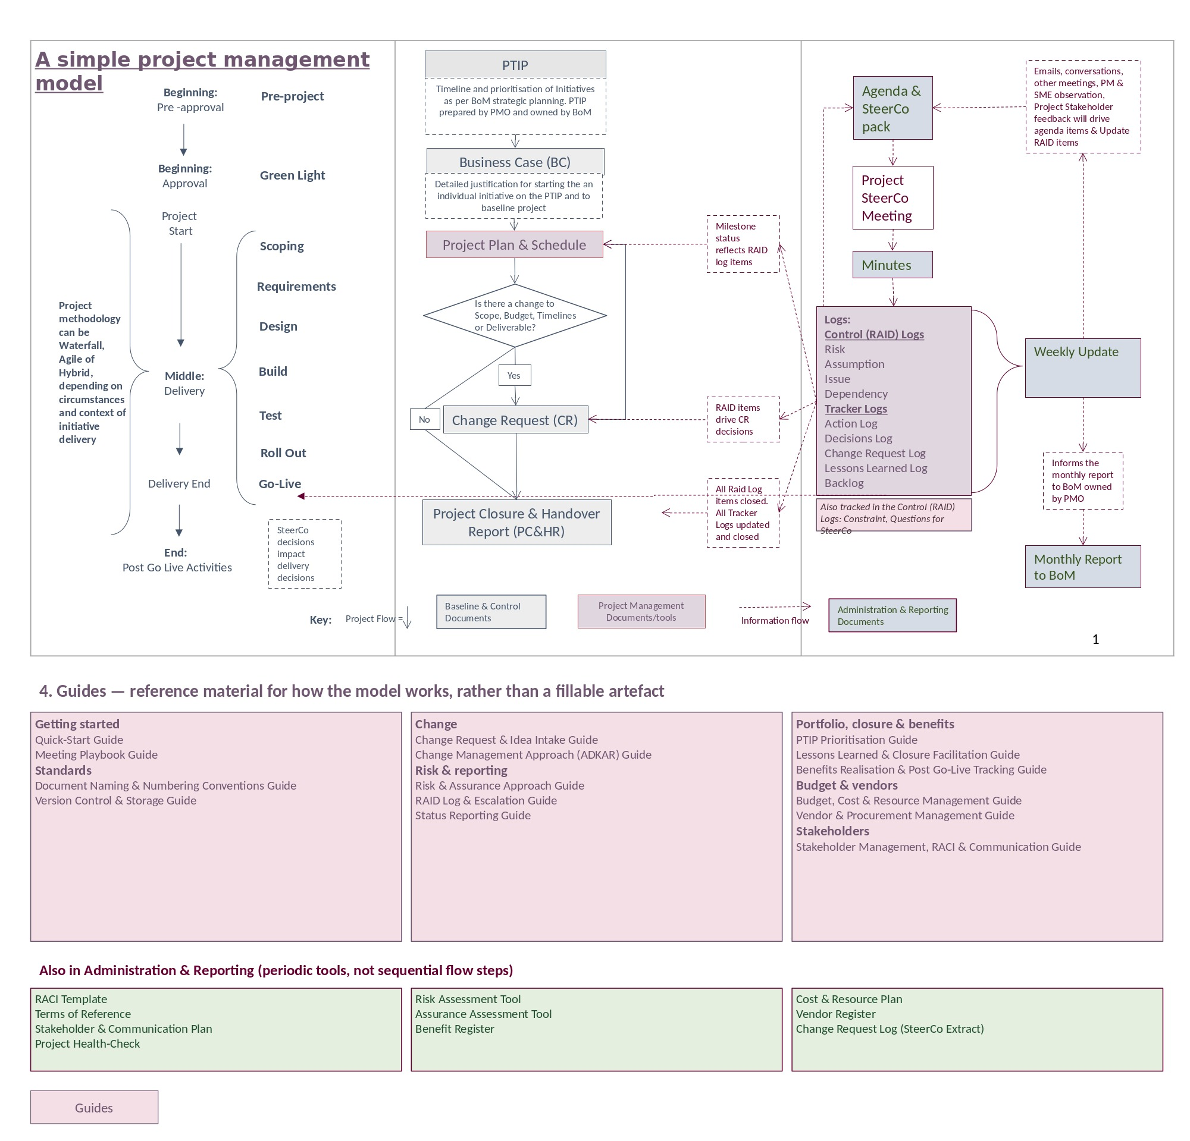

2.1 Lifecycle stages
- Pre-project — pre-approval; the initiative exists only as a line on the PTIP.
- Approval (Green Light) — the Business Case is approved and the project is baselined.
- Delivery — Scoping, Requirements, Design, Build, Test, Roll Out, Go-Live. The delivery methodology (Waterfall, Agile, or Hybrid) is chosen per project; SSLM does not mandate one.
- Post Go-Live — handover activities and benefits tracking.
Within this lifecycle, five points act as stage gates — where the deeper Risk and Assurance Assessment tools (see the Risk & Assurance Approach Guide) and periodic housekeeping (see the Version Control & Storage Guide) apply: Green Light, Design sign-off, Build complete, Go-Live, and Post Go-Live closure.

2.2 Four document panels
- Baseline & Control — the documents that justify, baseline, and close a project.
- PM Documents-Tools — the working tools used to run delivery day to day.
- Administration & Reporting — the governance and reporting cadence around the project.
- Guides — reference material explaining how a mechanism works, rather than a fillable artefact.

2.3 Tiers
SSLM scales through four tiers, stepping up only on a real trigger (Principle 8, see §1.5):
- Tier 1 — Core. The default. Every project starts here, using the standard document set in this pack.
- Tier 2 — Extended. The same single project, with additional blocks or deeper assurance added only when a real trigger requires them — still run entirely from this core pack.
- Tier 3 — Program. Multiple related projects coordinated together, sharing constraints and a rolled-up view (SSLM Enterprise Extension).
- Tier 4 — Portfolio. A standing portfolio office or EPMO governing programs and projects across the organisation (SSLM Enterprise Extension).
Most projects never leave Tier 1–2. The SSLM Enterprise Extension exists only for the Tier 3–4 scale referenced in section 8.

3. The Critical Path
The mechanism that makes the model traceable is the Project Reference: a single number, in the format YYYY-NNN (e.g. 2026-001), assigned when an initiative is first logged on the PTIP. That same number is carried, unchanged, into every downstream document.
The sequence below shows how a project moves through the model and where the Project Reference travels with it:
- Idea on a Page — a new idea or change idea is captured, assigned the next Idea ID, and logged in the Idea Log.
- PTIP — the initiative is logged and assigned its Project Reference.
- Business Case — justifies and baselines the initiative under the same Reference.
- Project Plan & Schedule — the working baseline; carries the Reference forward.
- RAID and Tracker Logs — risks, issues, decisions, actions, and backlog items are logged continuously through delivery, each with its own item ID within the one project workbook.
- SteerCo Agenda → Meeting → Minutes — governance cycle; decisions and actions recorded in Minutes flow back into the Decision and Action logs.
- Weekly Update — short-cycle status to stakeholders, drawn from the Project Plan and RAID logs.
- Change Request — raised only if scope, budget, timeline, or a deliverable needs to change; references the RAID item that triggered it and updates the Project Plan once approved.
- Monthly Report to BoM (Monthly Project Summary → Portfolio Roll-up) — monthly synthesis of the month's Weekly Updates, rolled up across all initiatives for the Board of Management.
- Project Closure & Handover Report — closes the project once all RAID and Tracker items are closed, referencing the same Project Reference throughout.

4. Document Library
All templates are held in the SSLM Framework Pack, organised into four folders matching the categories below.

4.1 Baseline & Control
Document | Format | Purpose | Typical owner
Idea on a Page | PowerPoint | Single-page intake form for a new idea or a change idea — the front door of the model. | PMO
Idea Log | Excel | Portfolio-level register of every idea and change idea, from submission through triage to its outcome. | PMO
PTIP | Excel | Portfolio-level prioritisation; assigns the Project Reference. | PMO, owned by BoM
Business Case | Word | Justifies and baselines an individual initiative. | Project Sponsor / PM
Project Closure & Handover Report | Excel (2 tabs) | Confirms scope, budget, and timeline delivered; closes all logs. | Project Manager

4.2 PM Documents-Tools
Document | Format | Purpose | Typical owner
Project Plan & Schedule | Excel | Milestone baseline; the spine everything else rolls up to. | Project Manager
Change Request Form | PowerPoint | Raised when scope, budget, timeline, or a deliverable changes. | Project Manager
RAID and Tracker Logs | Excel (12 tabs) | Risks, assumptions, issues, dependencies, constraints, SteerCo questions, decisions, actions, change requests, lessons learned, and backlog — one workbook per project. | Project Manager

4.3 Administration & Reporting
Document | Format | Purpose | Typical owner
Steering Committee (SteerCo) Pack | PowerPoint | Board meeting pack: agenda, decisions, actions, RAID, financials. | Project Manager
Weekly Update | PowerPoint | Short-cycle status to stakeholders. | Project Manager
Change Request Log (SteerCo Extract) | PowerPoint | CR pipeline view, pasted into the SteerCo pack appendix each meeting. | Project Manager
Monthly Report to BoM | Excel (4 tabs) | Per-project monthly summary rolling up into a portfolio view. | PM / PMO
Minutes | Word | Meeting record; decisions and actions reference the log IDs directly. | Minute taker
Project Health-Check | Excel | Periodic self-assessment of governance quality (not a status report). | Project Manager
Risk Assessment Tool | Excel (2 tabs) | Structured walk-through of the risk process, scored stage by stage. | Project Manager
Assurance Assessment Tool | Excel (2 tabs) | Deeper governance maturity check across 13 dimensions, run at key stage gates. | Project Manager / PMO
RACI | Excel | Role clarity per plan activity, with its own RACI ID per row. | Project Manager
Stakeholder & Communication Plan | Excel (2 tabs) | Stakeholder map plus the communication schedule that follows from it. | Project Manager
Benefit Register | Excel (2 tabs) | One line per Business Case benefit, baselined at go-live and reviewed once at its horizon. | Project Manager / Outcomes owner
Cost & Resource Plan | Excel (2 tabs) | Budget baseline, actuals, forecast, and resource schedule that sit behind the Weekly Update. | Project Manager
Vendor Register | Excel (2 tabs) | One row per vendor engagement, linked to related RAID items, milestones, and Change Requests. | Project Manager
Terms of Reference | Word | SteerCo's mandate, membership, and operating rules. | PMO
Design Principles Register | Excel (3 tabs) | Which Design Principles a project has adopted, complexity appetite, the low-maintenance target checked at closure, and a log of technical debt from approved exceptions. | Project Manager / Accountable owner

4.4 Guides
Document | Format | Explains
Change Request & Idea Intake Guide | Word | How new ideas and change requests are triaged, approved, and fed into the PTIP.
Change Management Approach (ADKAR) Guide | Word | A people-change methodology for managing the human side of change (distinct from Change Request control).
Meeting Playbook Guide | Word | How to plan, run, and follow up on the recurring meetings the model relies on.
Risk & Assurance Approach Guide | Word | The risk management process and how to use the Risk Assessment and Assurance Assessment tools.
Document Naming & Numbering Conventions Guide | Word | The file naming convention and the master ID Conventions lookup.
Version Control & Storage Guide | Word | Version control principles, a recommended folder structure, and storage hygiene.
Stakeholder Management, RACI & Communication Guide | Word | How stakeholder mapping, RACI, and communication planning fit together.
Quick-Start Guide | Word | A day-one walkthrough for picking up the pack to start a new project.
Status Reporting Guide | Word | How Weekly Update, Monthly Report, and Portfolio Roll-up connect, and the RAG/Trend language used across them.
RAID Log & Escalation Guide | Word | Thresholds for when a risk, issue, or question needs to escalate beyond the Project Manager.
PTIP Prioritisation Guide | Word | How initiatives are scored, ranked, and funded at portfolio level.
Lessons Learned & Closure Facilitation Guide | Word | How to run the closure session and capture lessons that get used.
Benefits Realisation & Post Go-Live Tracking Guide | Word | How benefits are baselined, handed over, and checked after go-live, and how to use the Benefit Register.
Budget, Cost & Resource Management Guide | Word | Keeping spend and resource visible and rolled up, and how to use the Cost & Resource Plan.
Vendor & Procurement Management Guide | Word | Selecting, onboarding, managing, and closing out vendors, and how to use the Vendor Register.
Design Principles Guide | Word | Declaring complexity appetite, the Simple Solution / Low Maintenance principle clusters, the exception rule, and the low-maintenance target.
Delivery Methodologies Guide | Word | How SSLM runs with Waterfall, Agile and value streams — what stays constant and what changes in each.
Why SSLM (Leadership One-Pager) | Word | The case for SSLM and what it improves — overall and per delivery method. A one-page leadership summary.
Getting Started in Project Management (New PM & PMO) | Word | A beginner's learning guide: the fundamentals of project management, how to apply them with SSLM, and why SSLM is a good framework to start with.

5. ID Conventions Glossary
One consistent set of identifiers runs through every document. Use this table as the master lookup.
ID type | Format | Example | Where used
Idea ID | IDEA-NNN | IDEA-001 | Idea on a Page, Idea Log
Project Reference | YYYY-NNN | 2026-001 | PTIP, Business Case, Project Plan, Closure Report, Monthly Report
Milestone ID | M# | M1 | Project Plan & Schedule
Risk ID | R### | R001 | RAID Log
Assumption ID | AS### | AS001 | RAID Log
Issue ID | I### | I001 | RAID Log
Dependency ID | D### | D001 | RAID Log, Project Plan (Dependency column)
Constraint ID | C### | C001 | RAID Log
SteerCo Question ID | Q### | Q001 | RAID Log, SteerCo Pack
Decision ID | DEC### | DEC001 | RAID Log, Minutes, SteerCo Pack
Action ID | X### | X001 | RAID Log, Minutes, SteerCo Pack
Change Request Number | CR-NN | CR-01 | Change Request Form, CR Tracker, CR Log
Lessons Learned ID | LL### | LL001 | RAID Log
Backlog ID | BL### | BL001 | RAID Log
RACI ID | RACI### | RACI001 | RACI
Debt ID | TD-NNN | TD-001 | Technical Debt Log

6. Roles Glossary
Role titles are standardised across the pack. Where a document previously used a different label, treat it as the same role below.
Role | Definition
Project Sponsor | The senior accountable executive for the project. Chairs the SteerCo. (Previously also labelled Project Executive or Executive Sponsor in some documents — now standardised.)
Business Owner | The business-side owner accountable for benefits realisation and for accepting project deliverables. (Previously also labelled Project Owner — now standardised.)
Project Manager (PM) | Day-to-day delivery lead; owns the Project Plan, RAID and Tracker Logs, and reporting cadence.
PMO / Head of PMO | Portfolio-level support and governance function; maintains the PTIP and supports SteerCo administration. On the SteerCo, holds a voting seat and may hold the Project Sponsor's delegated voting authority (see Terms of Reference).
Senior User | Represents user interests on the SteerCo.
Senior Supplier | Represents delivery/technical interests on the SteerCo.
SteerCo (Steering Committee) | The project's governance forum; meets regularly and makes key decisions. (Previously also called Project Board — standardised to SteerCo throughout the pack.)
BoM (Board of Management) | The portfolio-level governing body that owns the PTIP and receives the Monthly Report to BoM.
IT Liaison | Non-voting standing SteerCo member; responsible for the day-to-day technical aspects of delivery. Supports the PM to deliver approved deliverables and outcomes.
Business liaison/SME | Non-voting standing SteerCo member; responsible for the day-to-day business/user aspects of delivery. Supports the PM to deliver approved deliverables and outcomes.
Project Business Analyst | Supports the Project Manager with requirements analysis, process documentation, and translating business needs into project deliverables.
Director of Finance | Consulted (RACI) on changes with material cost or budget impact — see the Change Request Form.
Project Finance | Completes and signs off the financial sections of the Project Closure & Handover Report (payables, actuals, budget reconciliation). Distinct from Director of Finance, who is consulted on Change Requests with material cost impact.
Change Manager | Completes and signs off the change-management sections of the Project Closure & Handover Report (training, support materials, BAU handover). Works alongside the Project Manager on the people side of change — see the Change Management Approach (ADKAR) Guide.
Custodian | Owns the SSLM framework itself — the standard starter set of principles and templates, and the exception method that governs deviating from them. Not a per-project role.

7. Governance Rhythm
The reporting cadence that keeps the critical path alive:
- Weekly — the Project Manager issues the Weekly Update to stakeholders.
- Each SteerCo cycle — Agenda & SteerCo Pack is issued, the meeting is held, Minutes are recorded, and the Decision and Action logs are updated from those Minutes.
- Monthly — the Project Manager prepares a Monthly Project Summary from that month's Weekly Updates; the PMO rolls all active projects' summaries into the Monthly Report to BoM.
- As needed — a Change Request is raised whenever scope, budget, timeline, or a deliverable needs to change; approval updates the Project Plan and is reflected at the next SteerCo cycle.
- At closure — the Project Closure & Handover Report confirms every RAID and Tracker item is closed before the project reference is retired from active reporting: setting Status to Complete or Withdrawn on the Closure Report is what retires it.

8. Enterprise Extension (Optional)
A separate, optional module — the SSLM Enterprise Extension — sits alongside this pack for organisations operating at Tier 3-4 scale: running value streams, standing up a portfolio office, or governing multiple programs and projects together. It is picked up only when a real trigger appears, per Principle 8 (Right-size governance, see §1.5) — most projects will never need it.
It contains:
- Flow-to-Executive Translation Guide and the Executive Stream One-Pager tool — converting team flow into board-ready decisions for a value stream.
- EPMO Build & Maturity Guide — standing up and maturing a portfolio office.
- Programs & Portfolios Guide — what's genuinely new when SSLM scales above a single project.
- Coexistence with Established Methods — how SSLM sits alongside PRINCE2, PMBOK and SAFe.
Nothing in the Enterprise Extension changes the eleven governance principles or the Design Principles — it applies them with additional instruments, at a higher altitude.

